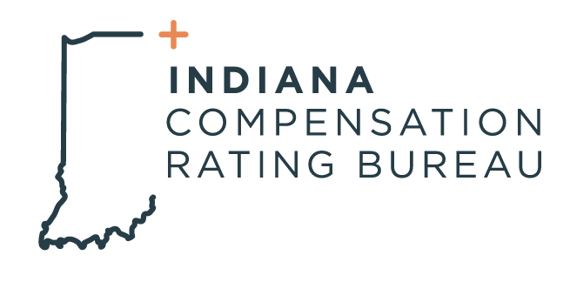

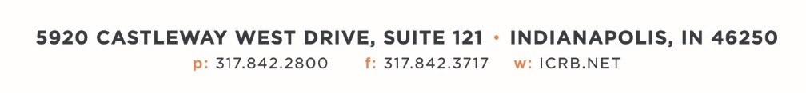

December 9th, 2025

ICRB GOVERNING BOARD MEETING AGENDA

Date: | Tuesday, December 9th, 2025
Time: | 9:00am
Location: | ICRB Board Room (this is a hybrid meeting, so you also have the option of attending via Teams, link below:
Join the meeting now
Meeting ID: 235 991 230 335 79
Passcode: hS3pL2N4

- Welcome
- Anti-Trust Statement
- Approval of previous Governing Board meeting minutes, September 23, 2025
- Trustee/Reinsurance Pool Report (Jeff & Barrett)
- Paralysis Claim Summary- Barrett
- Servicing Carrier Audit
- State of the State presentation- Paul & Scott
- Legal RFP Process
- SOC Audit Update
- Annual Budget- Jenn
- AR Pool Re-Insurance Discussion- Executive Session
- Operational Metrics- Scott and Jenn
- Update on ICRB Activities-
- Other Business
- Executive Session

