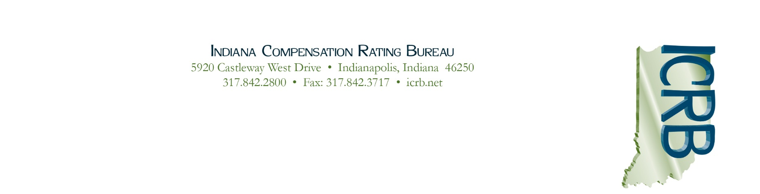

June 5, 2020

ICRB Governing Board
Meeting Agenda

In accordance with ICRB Bylaws Article IX.5, this document provides written
notice of the meeting to all Members and is posted on ICRB’s website.

Date: | June 11, 2020
Time: | 9:00 AM
Location: | Zoom Virtual Meeting (due to COVID-19 pandemic)

Agenda:

- Welcome
- Anti-trust Statement
- Approval of March 12, 2020 Minutes
- Reinsurance Pool Trustee Meeting Report
- VP Transition
- Duane Schroeder- Retirement and Special Projects
- COVID-19 updates
- Servicing Carrier Bid Process
- Return to Work Update
- Financial Audit
- Pension Update
- Website/New Logo Unveiling and Update
- OnBoard system for Board materials
- ICRB Operations Report
- September Meeting – In person vs. Virtual
- Other Business

Executive Session to immediately follow for Board Members only.

