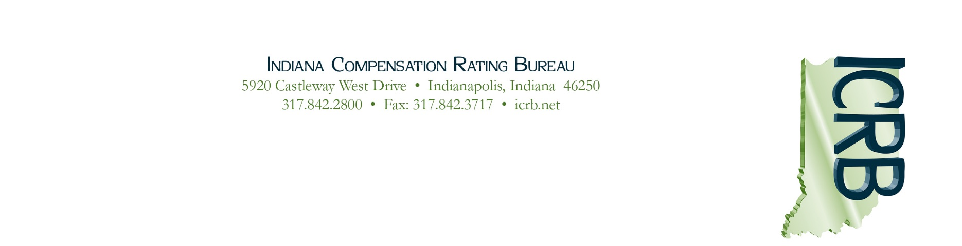

January 21, 2021

Circular 2021-02

Indiana Pool Take-Out Credit Program
Calendar Year 2020

Background
The Take-Out Credit (TOC) Program is a filed program in Indiana, effective since January 1, 1992. The program encourages carriers to remove employers from the assigned risk market by writing policies voluntarily in the regular market. It allows a carrier to obtain credits against its Pool participation.

For every dollar in premium removed, the carrier gets a dollar credit against its Indiana Pool participation base. The employer must stay out of the assigned risk market for at least one policy year. The carrier can earn the credit for up to three years. The credits are applied against a carrier's calendar year voluntary premium. Calendar year voluntary premium is used as the basis for the apportionment of the results (positive or negative) of the assigned risk market.

Summary of Calendar Year 2020 Procedures
To receive credits for Indiana, carriers must enroll with NCCI by February 19, 2021. For carriers that are currently enrolled in the NCCI system and/or received a take-out credit for Calendar Year 2019, you are already enrolled and are not required to enroll in the 2020 Take-Out Credit Program, just update your contact information, if needed. For more information, please refer to NCCI Circular PLAN-2021-04, dated January 8, 2021 which does a good job of explaining the process and provides sample forms.

As a service to the ICRB, NCCI is processing take-out credit requests for Indiana using its automated system. During the week of March 15, 2021, NCCI will send an email announcing the availability of the TOC Report located in its data collection tool, available online in the TOC System via NCCI’s data collection tool, Policy Data Collection.

If you agree with the TOC Report and have no changes, you must indicate your acceptance of the credits in the TOC System by April 16, 2021. Upon your acceptance, the NCCI TOC Administrator will notify the ICRB so that we may adjust your company’s Calendar Year 2020 voluntary market share. This will determine your company’s 2020 Indiana Pool participation base.

For more information, visit our website at www.icrb.net. Click on “Reference Library” at the top of the home page and go to “Assigned Risk: Take-Out Credit Program."

Sincerely,
Karen H. Byrd
President & CEO

