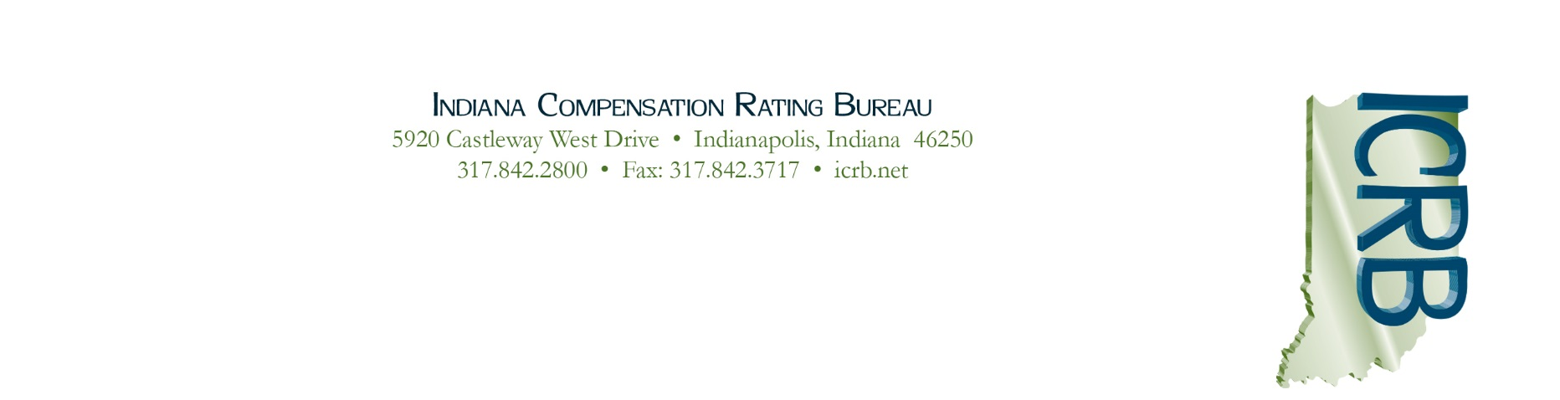

January 25, 2021

Circular 2021-03

To: ICRB Members

ANNUAL PREMIUM CALL
Indiana Pool - Due March 31, 2021

Note: We emailed this circular to our
member company contacts for premium calls.

Section 4.03 of the Articles of Administration for the Indiana Assigned Risk Reinsurance Pool (“Indiana Pool”) provides that each Member shall report to the Plan Administrator, in the form and manner prescribed by the Plan Administrator, the Net Premiums Written by such Member during each calendar year. Form IN-10 is used for this purpose.

Members claiming credit against their assessment base for employers written out of the Pool must be enrolled in the NCCI system by February 19, 2021. (Please refer to ICRB Circular No. 2021-02 for more information.)

Forms and instructions for completing and submitting the Premium Call can be found on the ICRB website (www.icrb.net). Click on “Assigned Risk” at the top of the home page. Under “Helpful Links,” select “Indiana Pool Premium Call.”

Additional Form Information:
- Form IN-10 must be filed even if no workers’ compensation premium was written in Indiana during the calendar year (simply enter 0 in column 1).
- Form IN-3 should also be submitted if the company contact information has changed:
Information for Your Annual Statement:
To complete your annual statements for 2020, the Indiana Pool NAIC number is AA-9991414. There is no FEIN for the Indiana Pool that applies for annual statement reporting. Prior to 2005, you would have used the number for the National Workers Compensation Reinsurance Pool (NWCRP) which is AA-9992118.

If you have any questions, please contact Barrett Hathcock at 601-977-9456.

Sincerely,
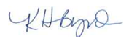
Karen H. Byrd
President & CEO

