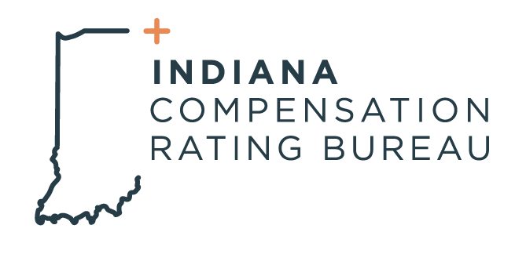

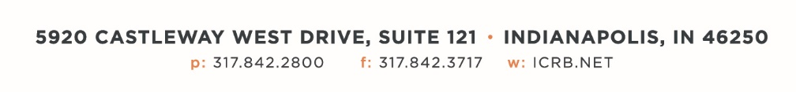

December 2, 2022

ICRB GOVERNING BOARD MEETING AGENDA

In accordance with ICRB Bylaws Article IX.5, this document provides written
notice of the meeting to all Members and is posted on ICRB’s website.
Date: | Tuesday, December 13, 2022
Time: | 9:00am
Location: | ICRB Board Room (this is a hybrid meeting, so you also have the option of attending via Zoom

- Welcome and Roll Call
- Anti-Trust Statement
- Approval of previous Governing Board Meeting minutes, 9/20/2022
- Introduction of Jennifer Cox
- Trustee/Reinsurance Pool Reports – Dave & Barrett
- Appointment of new Pool Trustees
- Finance Committee Report- 2023 Budget
- Contract Committee Report- CIS Contract renewal
- NCCI’s P-1409 Filing
- WCIO Meeting Update and ICRB’s Vice Chair role
- 2023 Servicing Carrier Bid Process & Contract renewal
- Training, Meetings and other
- Staffing & Operational Metrics
- Other Business
- Executive Session

