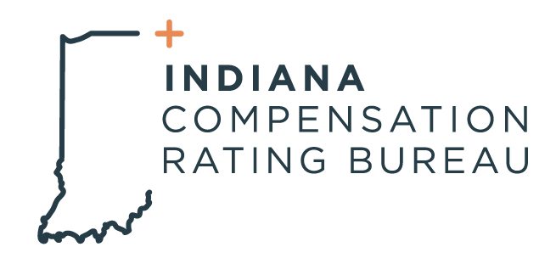

March 24, 2023

ICRB GOVERNING BOARD MEETING AGENDA

In accordance with ICRB Bylaws Article IX.5, this document provides written
notice of the meeting to all Members and is posted on ICRB’s website.

Date: Tuesday, March 28, 2023
Time: 9:00am
Meeting via In-person at ICRB conference room or via Zoom (link will be sent in email)

Agenda:
- Welcome and Anti-Trust Statement
- Approval of previous meeting minutes- December 13, 2022
- Assigned Risk Market Matters
  - Market Results- Kip Robbins (for Dave Franklin)
  - IN Pool Status- Barrett Hathcock
  - Distribution Guidelines and recommendation
- Workers Compensation Legislation Update
- NCCI Filings
- Conference Updates
- Assigned Risk Bid Process
- NCCI Contract Renewal
- Director of Finance Report
  - Financial Controls Manual
  - Audit Status
- Vice President Report
  - Staffing Update
  - Operational Metrics
  - Stakeholder Training
- Upcoming Events
- Executive Session

