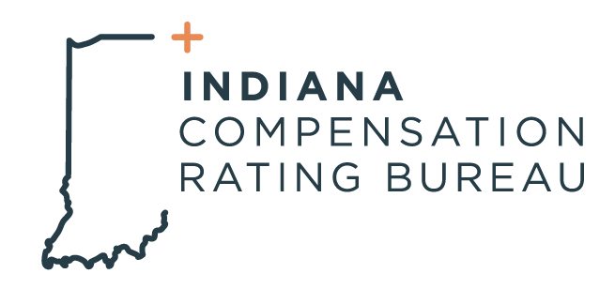

June 13, 2023

ICRB GOVERNING BOARD MEETING AGENDA

In accordance with ICRB Bylaws Article IX.5, this document provides written
notice of the meeting to all Members and is posted on ICRB’s website.

Date: Tuesday, June 20, 2023
Time: 9:00am
Meeting via In-person at ICRB conference room or via Zoom link in Calendar Invite

Agenda:
- Welcome and Anti-Trust Statement
- Approval of previous meeting minutes- March 28, 2023
- Assigned Risk Market Matters
  - Market Results- Dave Franklin
  - IN Pool Status- Barrett Hathcock
  - Distribution update

- Filings
- Conference Updates
- Introduction of new Board member, Michael Nunney
- Assigned Risk Bid Process
- Director of Finance Report
  - Audit Status
- President Report
  - Operational Metrics
  - Stakeholder Meetings
- Upcoming Events
- Executive Session

