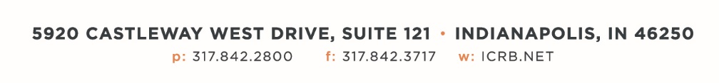

September 11, 2023

ICRB GOVERNING BOARD & ANNUAL MEETING AGENDA

In accordance with ICRB Bylaws Article IX.5, this document provides written
notice of the meeting to all Members and is posted on ICRB’s website.
Date: | Tuesday, September 19, 2023
Time: | Immediately following Annual Meeting (9:00am)
Location: | ICRB Board Room (this is a hybrid meeting, so you also have the option of attending via Zoom)

- Welcome and Roll Call
- Anti-Trust Statement
- Approval of previous Governing Board meeting minutes, June 20, 2023
- Election of Chair and Vice Chair
- Committee Appointments
- Trustee/Reinsurance Pool Reports – Dave & Barrett
- Reinsurance Options for the AR Pool- Guy Carpenter
- January 1, 2024, Advisory Rate, Loss Cost and Assigned Risk Rate Filing
- Reports about HR, Open position for Vice President
- Servicing Carrier Selection Results
- Item Filings B-1449 and R-1422
- Operational Metrics
- 2024 Meeting Dates
- Other Business
- Executive Session

