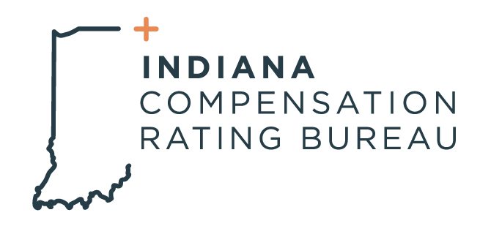

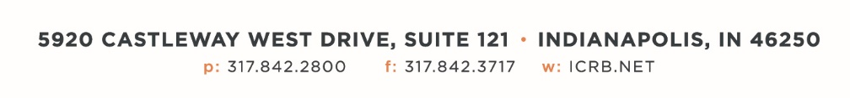

December 12, 2023

ICRB GOVERNING BOARD & ANNUAL MEETING AGENDA

In accordance with ICRB Bylaws Article IX.5, this document provides written
notice of the meeting to all Members and is posted on ICRB’s website.
Date: | Tuesday, December 12, 2023
Time: | 9:00am
Location: | ICRB Board Room (this is a hybrid meeting, so you also have the option of attending via Zoom)

- Welcome and Roll Call
- Anti-Trust Statement
- Approval of previous Governing Board meeting minutes, June 20, 2023
- Formal welcome and introduction of New Vice President, Scott Lerew
- Introduction of Allison Sidnam with Accident Fund as new Board representative.
- Trustee/Reinsurance Pool Reports – Dave & Barrett
- Update on Reinsurance- Guy Carpenter and Barrett’s analysis.
- Budget presentation and approval.
- NCCI Contract approval
- January 1, 2024, Advisory Rate, Loss Cost and Assigned Risk Rate Filing
- Item Filing RM-W-8050
- WCIO Update
- Operational Metrics
- Other Business
- Executive Session

